FINDING SPEED, TIME AND DISTANCE
- James completed a 100 m race in 11.7 seconds. What was his average speed in m/s?

- Leena walked from school to the shops in 10 minutes. If her average walking speed is 5 km/h, what is the distance from school to the shops?

- A dog, Zeto, likes to run around and burn up energy. If he runs up and down the yard with an average speed of 20 km/h, covering a total distance of 37 km, how long was he running around for?

- What is the average speed of an athlete who runs 400 metres in 50 seconds?

- What is the average velocity of a plane that flies 1000 kilometres north in a time of 4 hours?

- The following diagram shows the position of a moving car at three different times.

- If the car is moving from left to right, what indicates that it is speeding up?

- When would the diagram show that the car was slowing down?

- If the car is four metres long, how far did it move between the first and the third position?

- Use the diagram of the three ticker tapes to answer the following questions

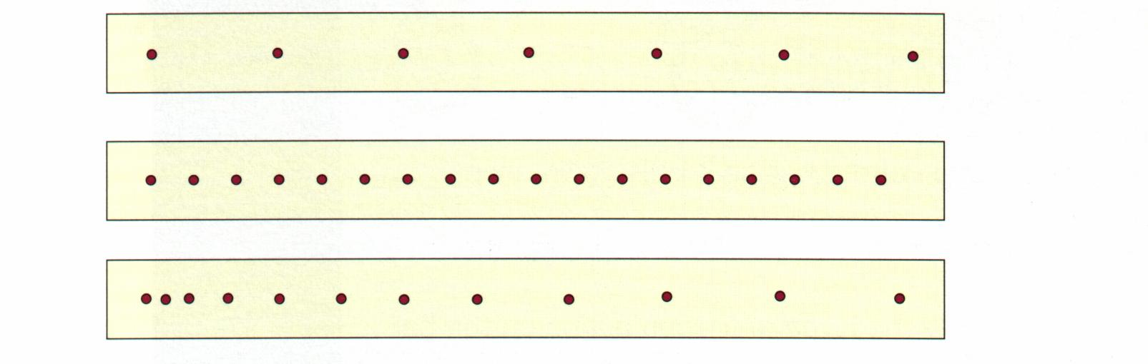
- Which tape shows a different type of motion from the other two?

- Which tapes were attached to an object that was travelling at constant speed?

- Which tape was attached to an object that was travelling the fastest?

- The following diagram shows the pattern of dots left on the ticker tape attached to a moving object.

- What does the pattern of dots indicate about the object’s motion?

- What was the time from when the first dot was made to when the last dot was made?

- How far did the object travel between the first dot and the last dot?

- What was the object’s average speed between making the first dot and the last dot?

